Step 1

After logging into the VM start run command prompt as an administrator

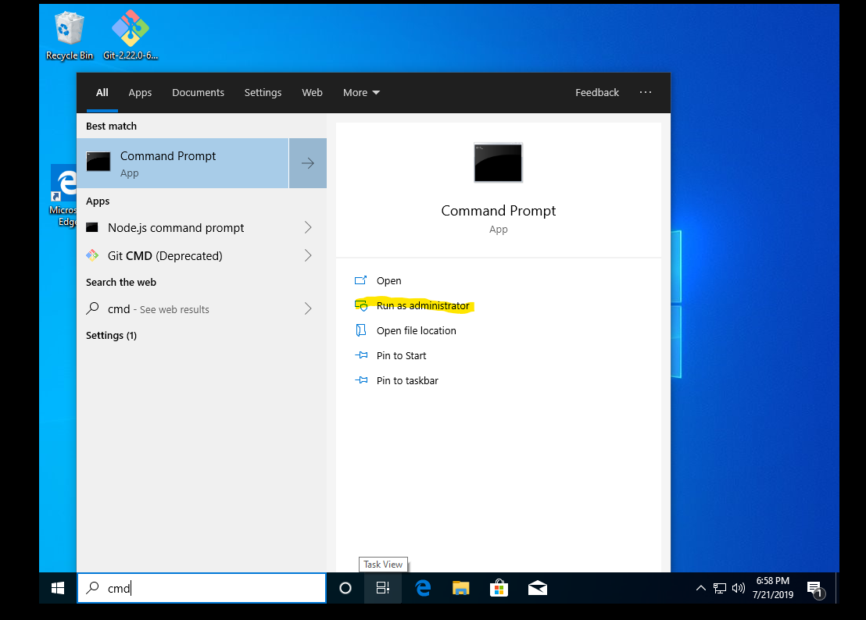

Step 2

Go back to the root directory by typing *CD ..* three times or *Cd C:\* and then go to the analyticalmetlx-master directory by typing *cd analyticalmetlx*-master. Once here type *sbt container:start*.

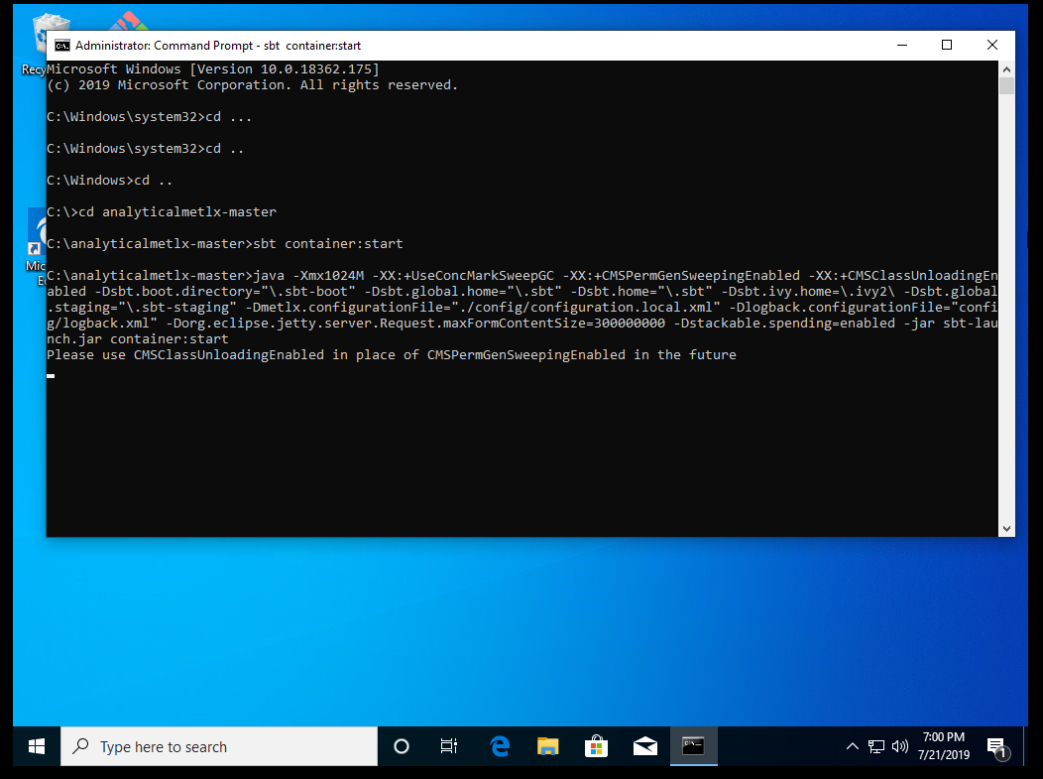

Step 3

Once it says success wait about 25 minutes before trying to log into the web browser.

